A2635-Eur-Russia-N Shore Black Sea-Scythian Reindeer Fibula-Bronze Rare- 6th-4th century BCE



Fig. 1. Eur-Russia-N Shore Black Sea-Scythian Reindeer Fibula-Bronze Rare- 6th-4th century BCE

**Case no.: 4**

**Accession Number: A2635**

**Formal Label:**

**Display Description:**

This openwork bronze reindeer is sculpted in classical Scythian style with a large body, large head, 6 antlers, 2 large front tines and pronounced musculature; the legs are folded beneath the body; the head is stretched forward with a large hanging dewlap; the facial features are stylized with a large, round eye. On the reverse side it has the original attachment loops.  
This bronze Scythian reindeer fibula was found in Kostromskaya, a *stanitsa* or rural locality near the north coast of the Black Sea.

**LC Classification:** NK7106.4.S38

**Date or Time Horizon:** Height: 3.7 cm (1.46 inches)

**Geographical Area:**

Kostromskaya (Russian: Костромска́я) is a rural locality (*stanitsa стани́ца*, IPA: ; Ukrainian: *станиця, stanytsia*) is a village inside a Cossack host (*viysko*) (*казачье войско, kazachye voysko*) in Mostovsky District of Krasnodar Krai, Russia, located at the foot of the Caucasus Mountains on the Psefir River (Fars' tributary, Kuban basin), 15 km (9.3 mi) southwest of the town of Labinsk.

**Map:**

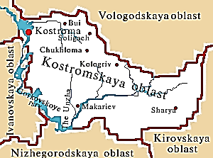

Left: Kostromskaya After <https://map.rin.ru/cgi-bin/main_e.pl?Region=kostroma>

Right: Scythia after https://pbs.twimg.com/media/Dfn5zWtWkAIxytu.jpg:large

**GPS coordinates:**

**Cultural Affiliation:** Scythian

**Medium:** bronze

**Dimensions:** 86.62 mm, 3.41 in

**Weight: 75 gm**

**Condition:** in good condition considering its age with a dark green patina.

**Provenance:**

Hands of History Ltd

18 Stonedene Close

Forest Row

East Sussex

RH18 5DB

United Kingdom

Phone:07852581546

Email:handsofhistory@hotmail.com

**Discussion:**

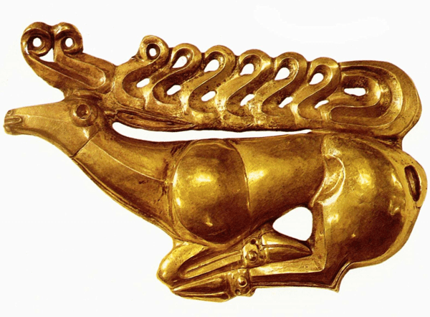

Fig. 2. 7th century BCE Scythian gold stag found on top of an iron shield it had adorned in the Kostromskaya Kurgan, and it is now in the Hermitage Museum in St Petersburg (Honour and Fleming 1982: 124). After https://www.scythianmuseum.org/portfolio/scythian-gold-deer/

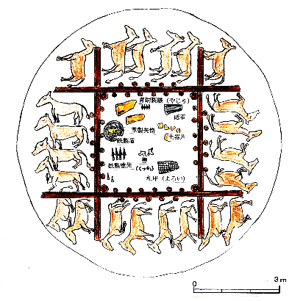

Fig. 3. The Kostromskaya Kurgan, which was excavated by the Russian archaeologist N. I. Veselovski in 1897, included thirteen humans encircled by twenty-two horses buried in pairs (Honour and Fleming 1982: 123; Piotrovsky 1974: 29). After https://upload.wikimedia.org/wikipedia/commons/thumb/7/7a/Horse_burials_and_artifacts_of_Kostromskaya_Kurgan.JPG/330

**References:**

Aruz, J. ed., 2000. *The Golden Deer of Eurasia: Scythian and Sarmatian Treasures from the Russian Steppes: the State Hermitage, Saint Petersburg, and the Archaeological Museum, Ufa*. Metropolitan Museum of Art.

Banker, E.C., 1996. Ancient bronzes of the eastern Eurasian steppes. *Santa Monica.*

Charriere, G., 1979. *Scythian art: crafts of the early Eurasian nomads*. Art Books Intl Ltd.Honour, Hugh and John Fleming. 1982. A World History of Art. London: Macmillan.

Minns, E.H., 2011. *Scythians and Greeks: A Survey of Ancient History and Archaeology on the North Coast of the Euxine from the Danube to the Caucasus*. Cambridge University Press.

Piotrovsky, Boris, *et al*. 1974. "Excavations and Discoveries in Scythian Lands", in From the Lands of the Scythians: Ancient Treasures from the Museums of the U.S.S.R., 3000 B.C.–100 B.C. The Metropolitan Museum of Art Bulletin, v. 32, no. 5.

Appendix

AP 9